**Name : Gourav Kumar Shaw**

**Enrollment Id. : 2020CSB010**

**Section: Gx**

**Subject : Computer Network Lab (CS 3272)**

**Assignment – 1**

**Q1. Read the man pages of ifconfig, ping, traceroute, arp, dig, nslookup, and netstat and write their utilities in brief.**

**Answer:**

**1. ifconfig**

* Ifconfig is used to configure the kernel-resident network interfaces. It is used at boot time to set up interfaces as necessary. After that, it is usually only needed when debugging or when system tuning is needed.
* If no arguments are given, ifconfig displays the status of the currently active interfaces. If a single interface argument is given, it displays the status of the given interface only.
* If a single -a argument is given, it displays the status of all interfaces, even those that are down. Otherwise, it configures an interface.

**2. ping**

* Checks if the internet connection to the destination host is available or not.
* Gives information about the round-trip delay in communicating with the host.
* Tells us the percentage of packet losses.
* Ping sends out an ICMP echo request to which it expects an ICMP echo reply response.

**3. traceroute**

* Helps figure out the routing hops data has to go through, as well as response delays as it travels across nodes.
* Enables us to locate where the data was unable to be sent along, known as points of failure.
* Print the route packets trace to network host.

**4. arp**

* Address Resolution Protocol (ARP) is a communication protocol used for **discovering the link layer address, such as a MAC address, associated with a given internet layer address, typically an IPv4 address**.

**5. dig**

* Query information about various DNS records.
* Dig (Domain Information Groper) is **a Linux command line utility that performs DNS lookup by querying name servers and displaying the result**

**6. nslookup**

* use to diagnose Domain Name System (DNS) infrastructure.
* If the host is an Internet address and the query type is A or PTR, the nslookup command returns the name of the host.
* If the host is a name and does not have a trailing period, the search list is used to qualify the name.

**7. netstat**

* Displays active TCP connections, ports on which the computer is listening, Ethernet statistics, the IP routing table, IPv4 statistics (forthe IP, ICMP, TCP, and UDP protocols), and IPv6 statistics (for the IPv6, ICMPv6, TCP over IPv6, and UDP over IPv6 protocols

**Q2. Find the IP and hardware addresses of your machine using ifconfig command.**

**Answer:**

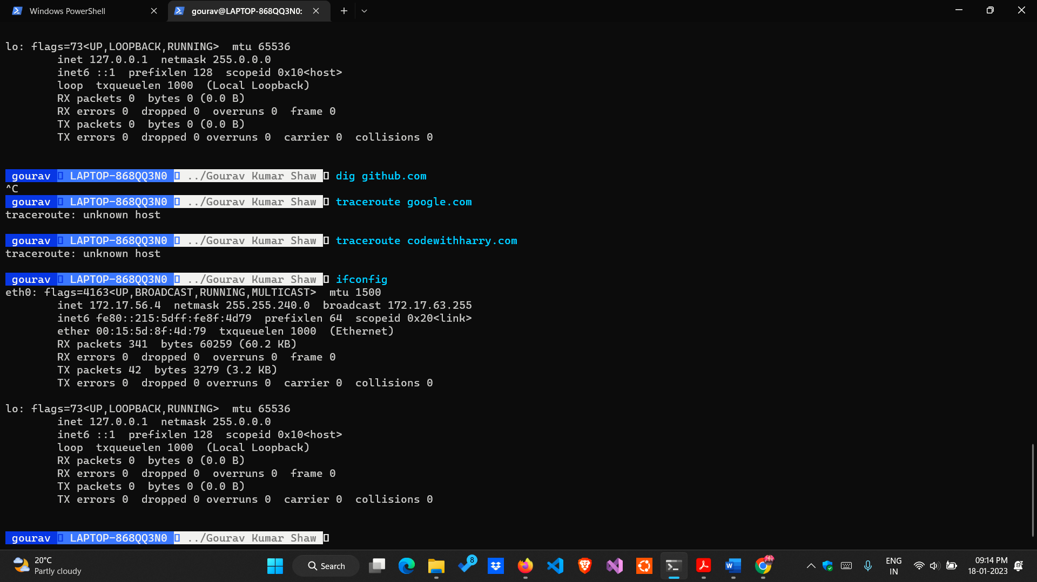

* IP address is: 172.17.56.4
* HW address is: 00:15:5d:8f:4d:79

**Q3. Use “ping <AnyURL>” command and find out**

**i. the average RTT(round trip time).**

**ii. the %packet loss.**

**iii. size of packet that is sent to <AnyURL> server.**

**iv. size of packet that is received by your machine.**

**Answer:**

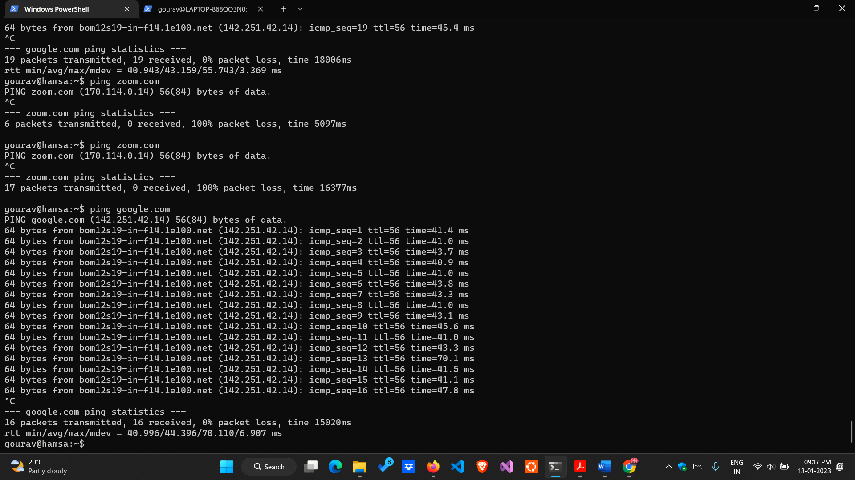

1. i. Average RTT is: 44.396 ms .
2. ii. Packet Loss is: 0%.
3. iii. Size of packet sent of google.com is: 56 bytes.
4. iv. Size of packet received is: 64 bytes.

**Q4. Use “dig <AnyURL>” command and find out**

**i. the IP address of <AnyURL>.**

**ii. the IP addresses of local DNS servers of IIEST**.

**Answer:**

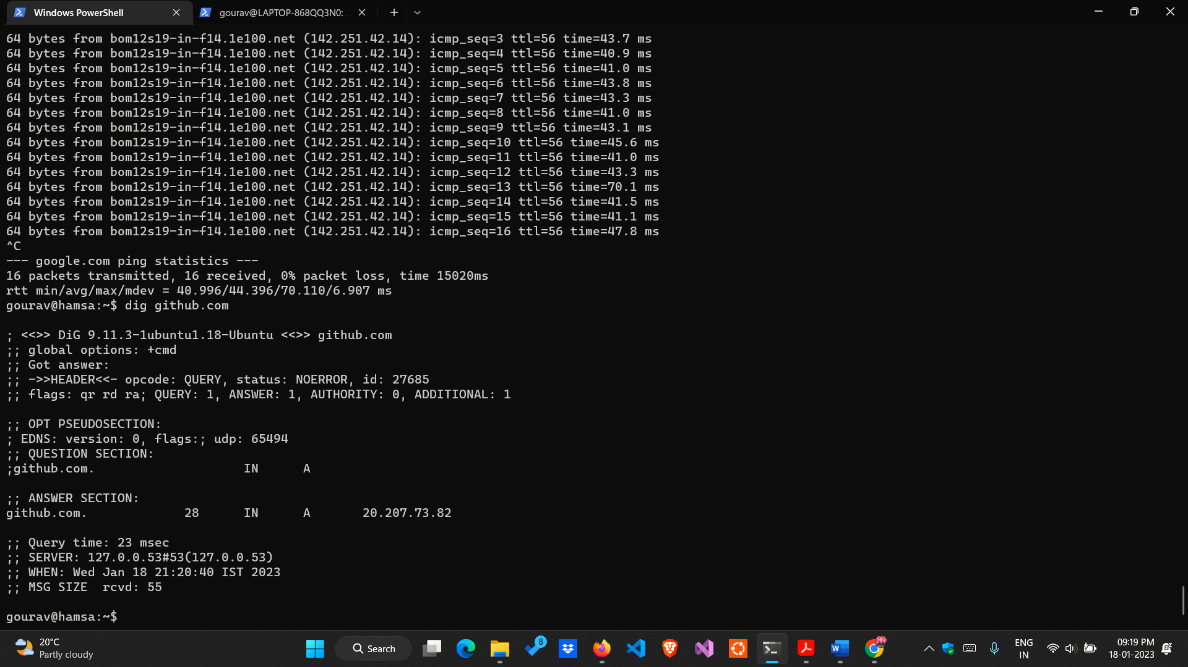

i. IP Address of github.com is 20.207.73.82

ii. IP addresses of local DNS servers of IIEST is 127.0.0.53

**Q5. Use “traceroute <AnyURL>” and find out**

**i. number of hops in between your machine and <AnyURL> server.**

**ii. the IP address of your network gateway of your subnet.**

**Answer:**

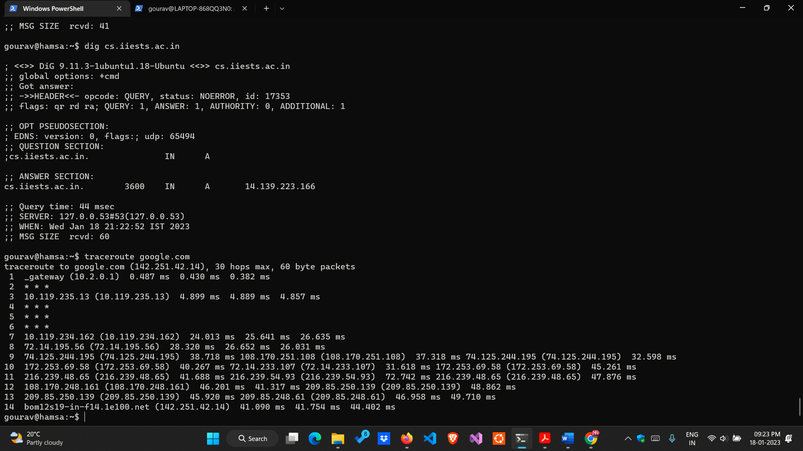

i. Number of hops between my machine and google.com is:14

ii. IP address of my network gateway is : 10.2.0.1

**Q6. Use “arp” command to find out the MAC address of the device that is performing as your network gateway.**

**Answer:**

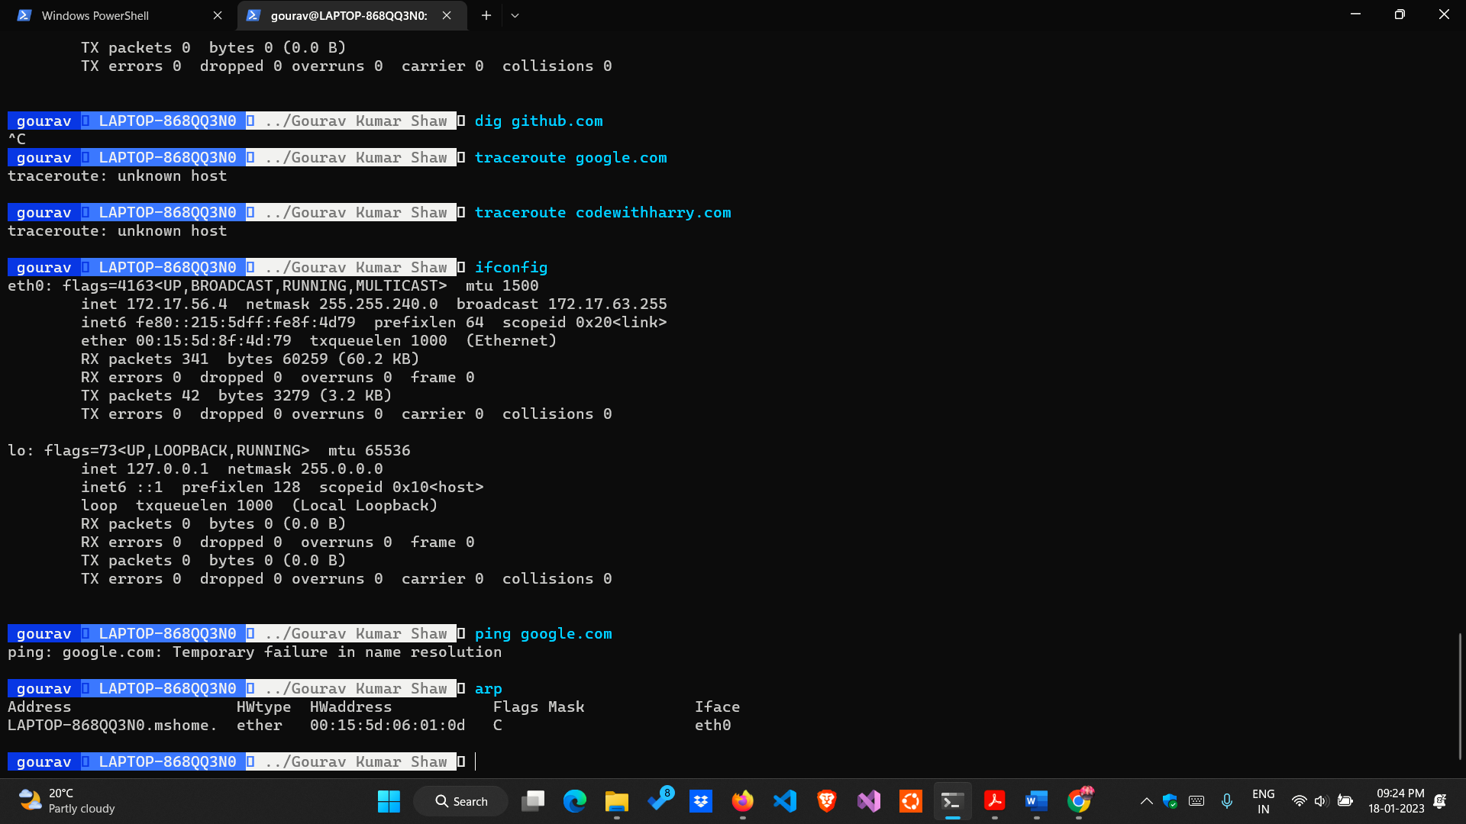

MAC address of the device that is performing as my network gateway is: 00:15:5d:06:01:0d

**Q7. Use nslookup <AnyURL> command and find out the IP address of <AnyURL>. Use nslookup <IP address> command and perform reverse domain lookup.**

**Answer:**

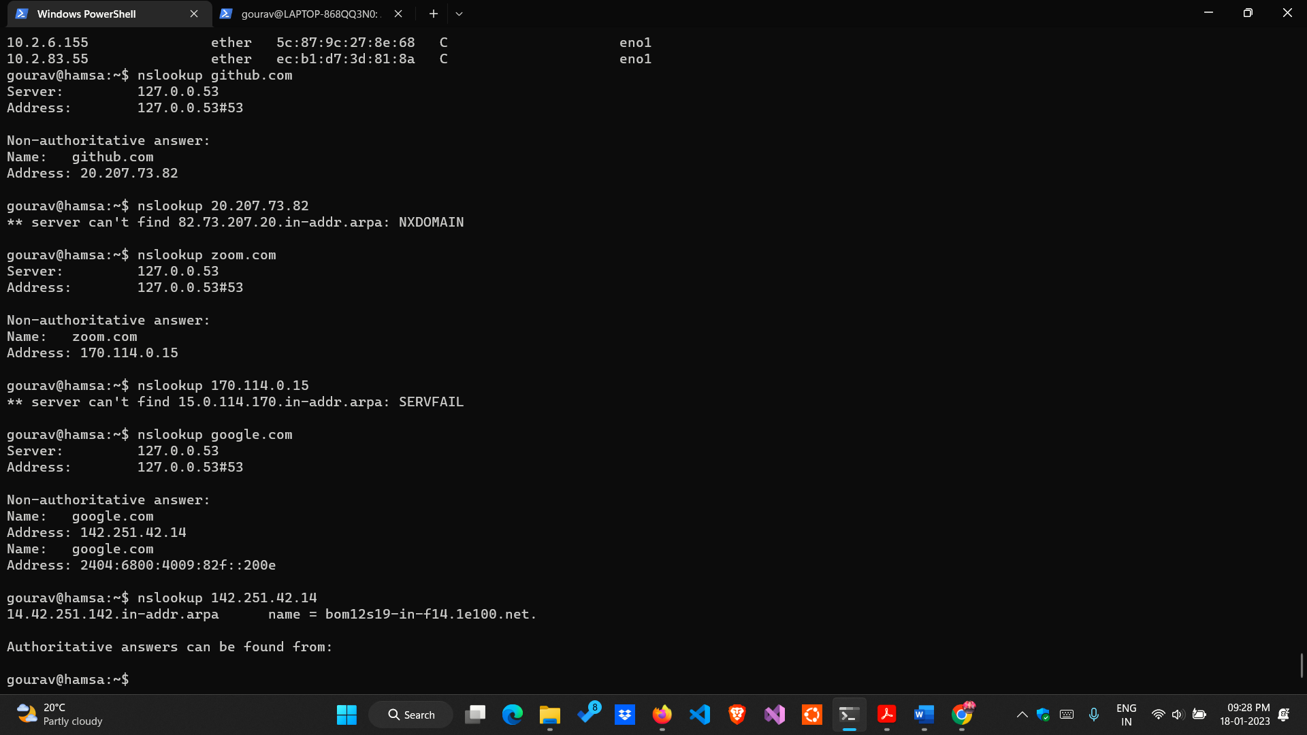

* IP address of google.com is (IPv4) : 142.251.42.14

and (IPv6): 2404:6800:4009:82f: :200e

* Doing a reverse domain lookup I got:

bom12s19-in-f14.1e100.net

**Q8. Use netstat command and find out the active connections of your machine.**

**Answer:**

